The framework I used to test the Apis Manually

Is postman to verify the request Urls and the Json responses and their status code and

Status lines, header and content

**Installation setup :**

Visual studio 2017 (Community)

Project created with Unit test(.Net Framework)

Please ensure installing from the NuGet Manager the Below Libraries/Packages

The Main library I used to be able to automate the Apis is RESTSHARP(C#)

Also Newtonsoft.Json used to read the Json response and be able to deserialize it into a C# object

Namespaces are defined within the project itself.

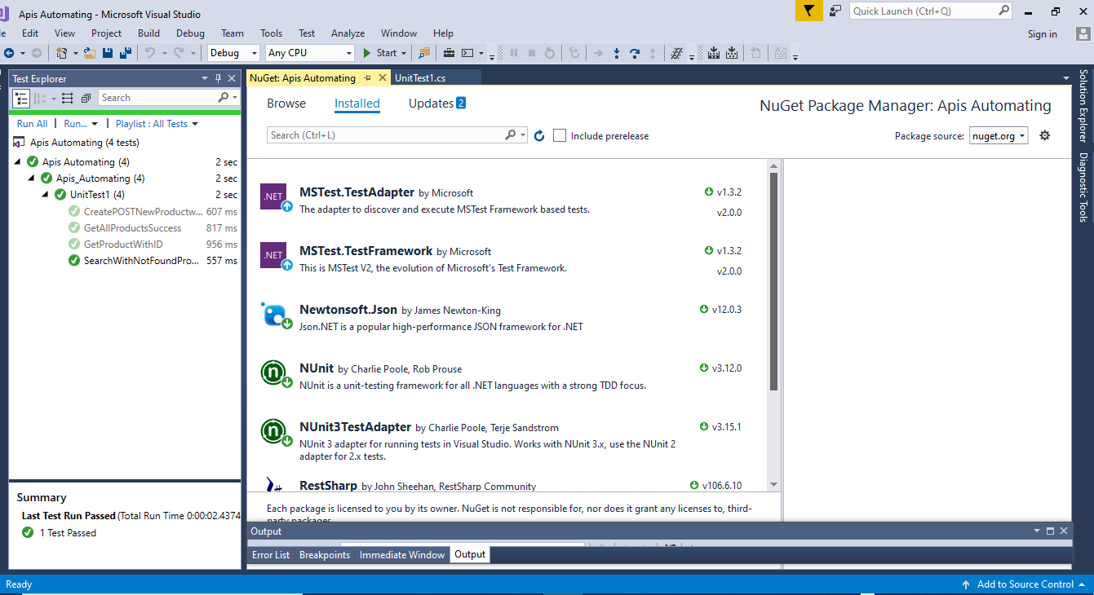

Ensure You’ve define the following namespaces in the test class

using System;

using Microsoft.VisualStudio.TestTools.UnitTesting;

using NUnit.Framework;

using RestSharp;

using RestSharp.Deserializers;

using RestSharp.Serialization.Json;

using System.Collections.Generic;

using System.Net;

using Newtonsoft.Json.Linq;

using Newtonsoft.Json;